**PREDICTING HOUSE PRICES USING MACHINE LEARNING**

**-M.PRIYADHARSHINI**

**INTRODUCTION:**

* Predicting house prices using machine learning is a project where the algorithms are used to analyze various factors such as location, size, number of rooms, and other features to estimate the price of house.
* By training the machine learning model with historical data, it can learn patterns and make predictions on new data.

**OVERVIEW:**

The overall, predicting house prices using machine learning involves a comprehensive data science pipeline, from data collection and preprocessing to

1. Model development

2. Evaluation

3. Deployment

**OBJECTIVE:**

* To develop a machine learning model that accurately predicts house prices based on various features.
* To provide a helpful tool for real estate professionals and individuals looking to buy or sell properties.

**HARDWARE REQUIREMENTS:**

The general hardware considerations for predicting house prices using machine learning are:

1. Processor

2. Memory

3. Storage

4. Graphics processing unit

5. Internet connection

6. Operating system

**BLOCK DIAGRAM:**

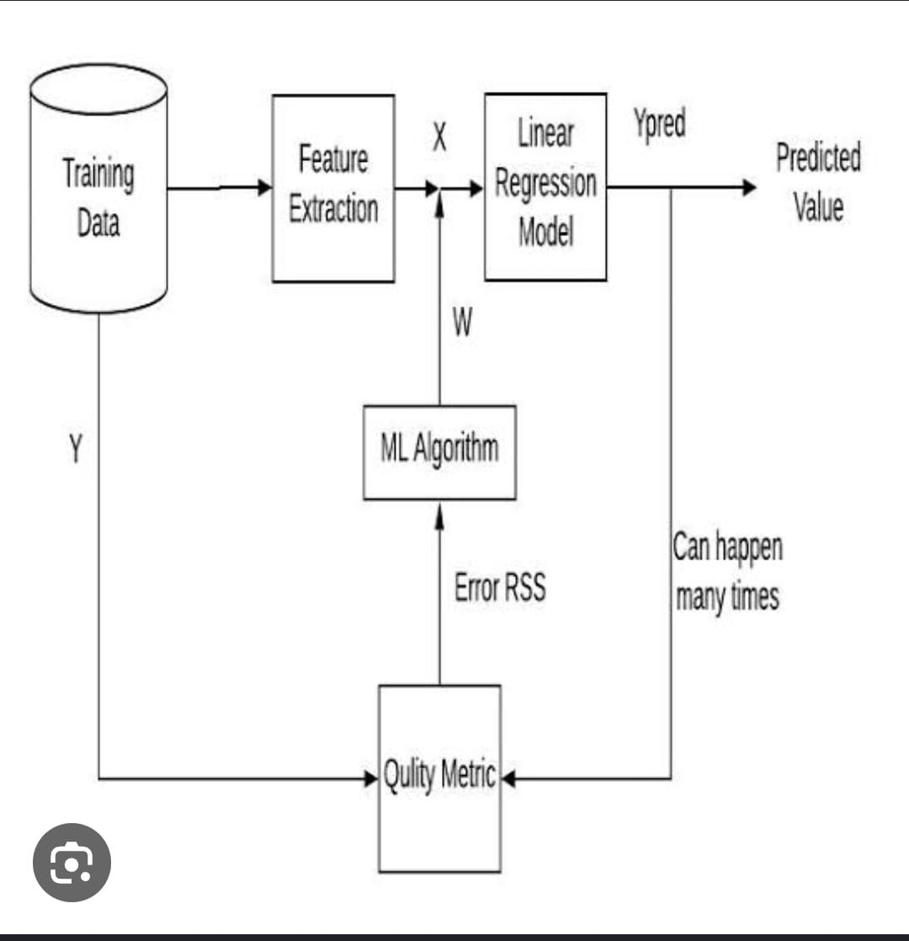

**SOFTWARE REQUIREMENTS:**

To develop the machine learning model for predicting house prices , the required software are

1. Python

2. Machine learning libraries

3. Data manipulation and analysis

4. Data visualization

**APPLICATIONS:**

* Real estate investment
* Fraud detection
* Property management
* Risk assessment
* Insurance pricing
* Urban planning
* Home renovation